Project Development Phase
Model Performance Test

Date | 03 October 2026
Team ID | SWTID-2026-4339
Project Name | Streamlining IT Procurement: Automating Standard Laptop Orders with Flow Designer
Maximum Marks

Model Performance Testing:
Project team shall fill the following information in model performance testing template.
S.No. | Parameter | Values | Screenshot
 | Model Summary | ServiceNow Flow Designer automation for standard laptop orders: a catalog request triggers a flow that routes manager approval, creates the procurement task and notifies the requester.  Note : If the request data is valid and approved, the procurement task is created; otherwise the flow stops and shows an error or rejection notice. | 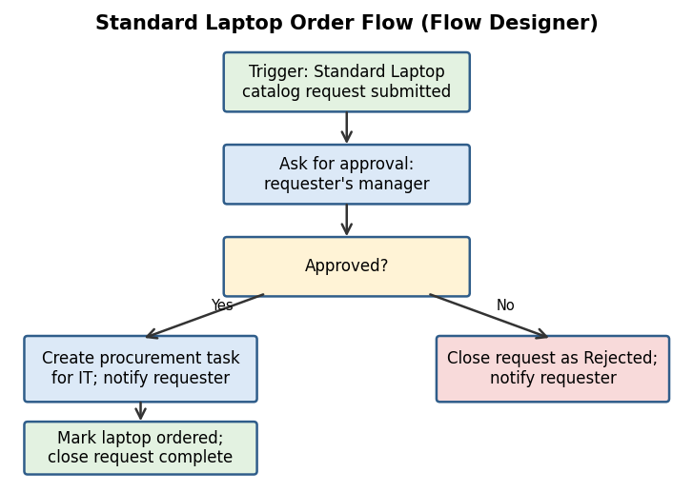
 | Accuracy | Training Accuracy - N/A (rule-based workflow, no machine learning model)  Validation Accuracy - N/A; validated through testing: 6 of 6 UAT test cases passed (100%) | 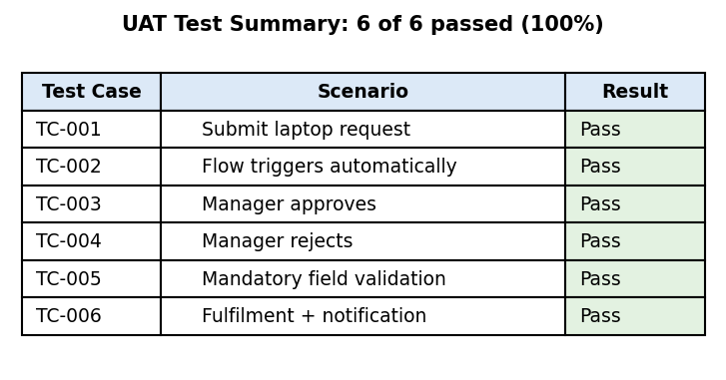
3. | Confidence Score (Only Yolo Projects) | Class Detected - N/A (not a YOLO / object detection project)  Confidence Score - N/A

